**Effect of non-catalytic surface on Methane Pyrolysis for Hydrogen and Carbon Production: an experimental and modelling approach**

Emmanuel Busillo*a*, Benedetta de Caprariis*a* , Paolo De Filippis*a* , Martina Damiziaa, Maria Paola Bracciale*a* Clarissa Giudicib & Matteo Pelucchi*b*

*a* Department of Chemical Engineering, Materials, Environment, Sapienza University, Rome, Italy

*b* Department of Chemistry, Materials, and Chemical Engineering, Politecnico di Milano, Milan, Italy

E-mail: Emmanuel.busillo@uniroma1.it

Methane pyrolysis presents a promising pathway for clean hydrogen production without direct CO₂ emissions. Although thermal methane pyrolysis has been extensively studied, the influence of non-catalytic surfaces on reaction performances and product formation remains insufficiently understood, limiting the possibility to valorise the carbon and make the process scale up economically feasible. This study investigates the effect of surface addition on methane pyrolysis in tubular quartz reactors. Experiments were conducted with high-purity methane (>99.9%) at atmospheric pressure and temperatures between 950 and 1150 °C. Two reactor configurations were examined: an empty reactor (i.d. = 1 cm) and one packed with inert ceramic spheres (d = 6 mm). Both setups were heated using an alumina-sheathed electric furnace with a fixed 20 cm heated zone and flow rates were adjusted to maintain comparable residence times. Carbon products were collected and weighed. Methane conversion, hydrogen yield, C₂ hydrocarbon content, and carbon morphology were analysed using online mass spectrometry (QGA Hiden), scanning electron microscopy (SEM), and transmission electron microscopy (TEM). Results were compared and analysed with detailed kinetic models developed by CRECK Modelling Group, obtaining good agreement. The outcomes indicate that the increased surface significantly affects product distribution and carbon deposition. The packed reactor showed reduced C₂ concentrations in the outlet gas and promoted carbon deposits with distinct morphologies. Notably, hemispherical carbon structures were observed growing from layered carbon surfaces on the ceramic spheres, suggesting complex interactions with soot particle formation. These findings underscore the importance of reactor surface design in optimizing thermal methane pyrolysis. Controlling internal surfaces can influence both gas-phase chemistry and solid carbon formation, offering a potential lever for improving process efficiency and carbon handling—key factors for scaling up turquoise hydrogen production technologies.

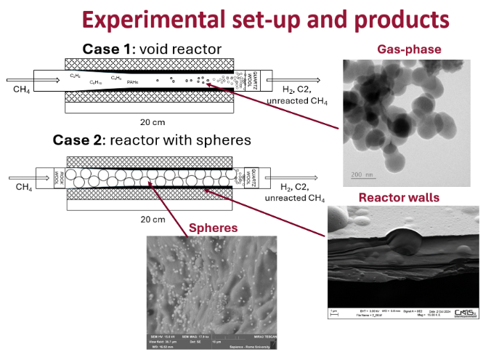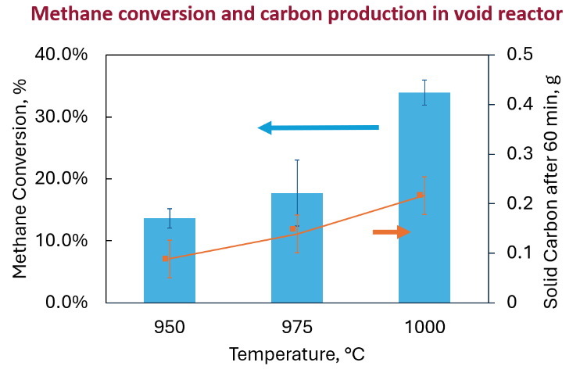**Keywords**: turquoise, hydrogen, *methane pyrolysis, carbon production*