Novel continuous cultivation of purple phototrophic bacteria fed with gaseous VFAs using L/G membrane contactor for single cell protein production
M. Pezzuto*, R. Lo Coco* and N. Frison*
*Department of Biotechnology, University of Verona, Strada Le Grazie 15, 37134 Verona, Italy
E-mail: nicola.frison@univr.it
Abstract
This study presents an innovative system for sustainable single-cell protein (SCP) production using purple phototrophic bacteria (PPB) cultivated in a photo-anaerobic bioreactor. Volatile fatty acids (VFAs), recovered from anaerobic fermentation of organic waste, are transferred in gaseous form via a membrane contactor (MC), eliminating direct contact with waste and ensuring safer, higher-quality protein biomass. The experimental system operated continuously for over 160 days, optimizing conditions such as organic loading rate (OLR), temperature, and gas transfer time. VFAs—mainly acetic, propionic, and butyric acids—served as the sole carbon source for PPB, enabling efficient photoheterotrophic growth under infrared illumination tailored to bacteriochlorophyll absorption.
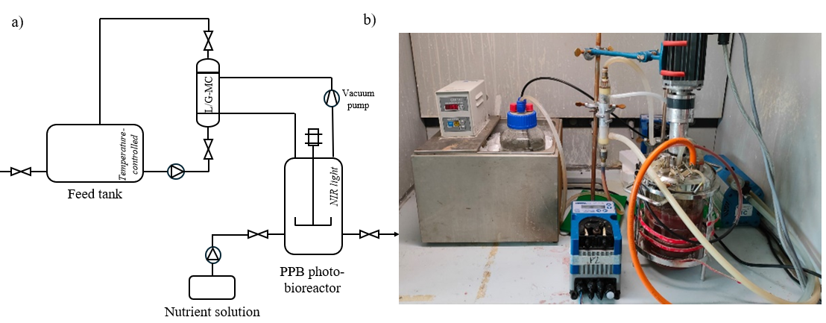
The process achieved a peak biomass production rate of 0.4 gMLVSS·L⁻¹·d⁻¹ and a crude protein content of up to 62%. The amino acid composition of the resulting biomass matched or exceeded key requirements for aquaculture feed, particularly in essential amino acids like leucine, methionine, lysine, arginine, and threonine. Additional valuable products such as pigments (mainly bacteriochlorophylls and carotenoids) and polyhydroxyalkanoates (PHA) were also present, further enhancing the nutritional value of the biomass. This coupled MC–bioreactor system offers a promising route for converting organic waste into high-value protein while avoiding ethical and regulatory concerns linked to direct waste contact. Its scalability and ability to recover multiple valuable products position it as a key technology for circular bioeconomy applications in the sustainable feed sector.
Keywords: Single Cell Protein (SCP), Purple Phototrophic Bacteria (PPB), Volatile Fatty Acids (VFAs), Membrane Contactor (MC), Photo-anaerobic Bioreactor

