Terahertz Technologies as New Frontiers for Pathogenic microorganism Sensing: Drawbacks, Potentialities and Applications

Annalisa D’Arco ^{1,*}, Salvatore Macis¹, Tiziana Mancini¹ and Stefano Lupi^{1,2}
¹ Department of Physics, Sapienza University, P.le A. Moro 2, 00185 Rome, Italy; annalisa.darco@uniroma1.it, salvatore.macis@uniroam1.it, tiziana.mancini@uniroma1.it, stefano.lupi@uniroma1.it
² INFN section Rome 1, P.le A. Moro 2, 00185 Rome, Italy stefano.lupi@roma1.infn.it

The rapid and accurate identification of pathogenic microorganisms is a topic of great relevance due to its notable importance in all areas related to human life, health and public safety, as also highlighted by recent events linked to the SARS-CoV-2 pandemic.
In the field of public health, the need for deployable tools for adequate, rapid and effective recognition on a large scale is of particular importance for the prevention and treatment of serious infectious diseases, and at the same time to prepare effective medical treatments and clinical therapies. Furthermore, in the field of food quality, food and water are potential sources of bacterial proliferation due to incorrect packaging and storage procedures, so accurate controls are necessary to guarantee product safety.
Currently, gold standards include conventional techniques based primarily on cell culture methods and molecular and/or biochemical recognitions, particularly for microbial pathogens, and molecular and immunological techniques for viral pathogens. They present some drawbacks regarding sensitivity, safety, laboriousness, long-term collection and analysis of data [1-4]. Therefore, since these methods are still limited, it is necessary to find new, precise and highly sensitive alternative solutions. Numerous biosensor platforms have been suggested to address these shortcomings, using electrical, mechanical, optical, and plasmonic approaches. They are all promising applications suitable for laboratory and clinical/medical investigations, with high potential for compact, portable, real-time and label-free detection. Among these different kinds of approaches, biosensor platforms based on optical sensing have gained considerable attention, such as THz spectroscopy, also in combination with THz nano- and metamaterials.
Despite the extensive and well-established attention paid to the microwave, infrared and visible regions, the small THz gap between microwave and infrared (0.1-10 THz, 3-330 cm⁻¹, 30 - 3000 μm) has long been ignored due to its technological difficulties in generation and detection. In recent years, the THz region has undergone a technological renaissance driven by improvements in sources, detector responses and the availability of new materials with a strong THz response [2,4-19]; promoting and accelerating the diffusion of THz technologies in several fields of scientific application, including pathogenic microorganism sensing [1,2,4,18,20].

In the context of biomedical and biochemical applications, THz radiation (4 meV @ 1 THz) is largely interesting because its low photonic energy (incapable of heating materials or inducing the ionization of atoms/molecules), provides non-destructive and non-ionizing detection, in contrast to other optical techniques, including ultraviolet or X-rays, where high-energy photons (>>eV) cause direct biological damage on the sample [18,21]. Furthermore, rotational and vibrational molecular modes and intermolecular vibrations, such as hydrogen bonds, typically dominate the THz frequency region [1,18]. Therefore, THz techniques directly identify the spectral properties of the material and offer chemical specificity to imaging experiments [18,19], which can be performed efficiently in label-free and non-contact modes. On the other hand, high sensitivity to water and low spatial resolution (around 100 µm) are the main disadvantages of THz radiation. The extreme sensitivity of THz radiation to polar molecules, specifically water, restricts the THz waves penetrability from tens to hundred microns in hydrated samples, preventing wide technological spread in biological fields [1,2,4,18,20]. Referring to THz spectroscopy, many layouts and materials are used for THz signal collection, showing high performance in terms of the signal-to-noise ratio (SNR) and coherent detection mode.

Interestingly, we used our transmission-mode THz time-domain spectroscopy (THz-TDS) system, detailed in Figure 1, to evaluate the response of bio-signatures of the desert cyanobacterium Chroococcidiopsis (CCMEE 057), subjected to strong ionizing ion irradiation during the STARLIFE irradiation campaign. In this application, we studied the dielectric properties of dried films of cyanobacteria, previously exposed to increasing doses of X-rays. By measuring both the amplitudes and phases of THz electric fields transmitted through the microbial samples, we extracted dielectric properties, including absorbance and refractive index of microbial films, using effective medium theory, specifically the Bruggeman model.
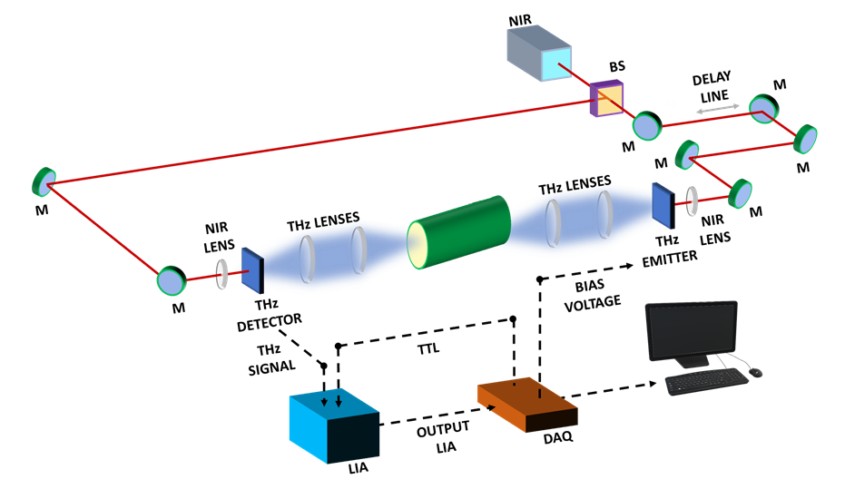

Figure 1. Schematic layout of THz-TDS setup in transmission mode based on switched photoconductive antennas (PCAs), available at Dept. of Physics, Sapienza University. A femtosecond near-IR (NIR) laser beam is divided in two parts by a beam splitter. Some mirrors (M) convey the laser beams to the THz emitter and receiver, where they are focused by a NIR lens. Here the THz beam is produced and detected, respectively. A stack of transparent THz lenses collimates and focuses THz radiation along the path and a sample holder is inserted into the THz propagation region. The acquisition chain consists of a Lock-in amplifier (LIA), a data acquisition card (DAQ) and a personal computer for data collection and analysis. The optical delay line is used to sample the THz pulse in the time domain.[10]

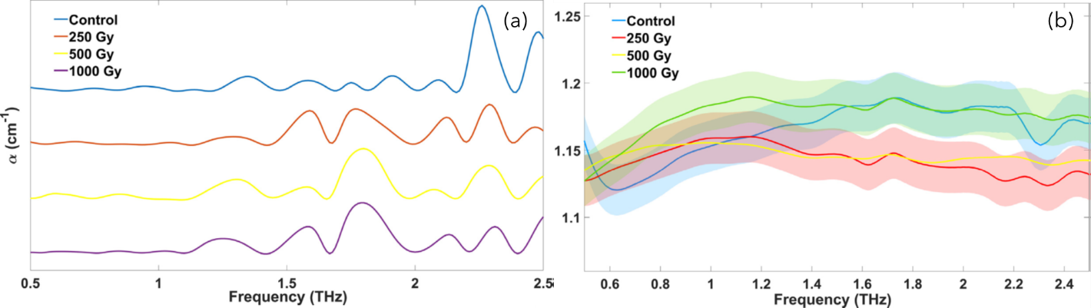

Figure 2. (a) THz absorption spectra and (b) refractive indices of dried CCMEE 057 films on Si substrate obtained from the Bruggeman model exposed to increasing X - rays doses, during the STARLIFE campaign. The spectral range is 0.5–2.5 THz.[20]

More extensive researches should be performed, previous results [2,4, 22], suggest that a direct microorganism THz detection is very difficult due to the virus low THz absorption coefficient and, in various cases, the absence of specific THz spectral features. Thus, THz spectroscopy can be used to study the optical properties, such as the refractive index and absorption coefficient, of different types of pathogens, the THz wavelength is much larger than the particle size of microorganisms. This results in very low spatial resolution and reduced sensitivity. However, incredible advances in the field of optics make it possible to maximize the interaction between radiation and biomaterial using plasmonic biosensors and metamaterials.
Meta- and nanomaterials, operating in the THz region, represent an attractive alternative and provide great potential for high-speed, on-site and label-free point-of-care virus detection [2,4]. Some previously examined plasmonic platforms, such as planar metal-dielectric biosensors, require simple and intelligent fabrication techniques to achieve low LODs. We explored pioneering studies on THz virus detection and reported technological efforts in THz metamaterial optical biosensors, highlighting the flexibility of a variety of geometric structures, their sensitivity, and LODs for various microorganism [2,4]. However, the strong potential of THz-based pathogens detection is still in the early stages of development and far from clinical use. However, recent technological improvements in the manufacturing and miniaturization of THz layouts promise to improve the performance of meta- and nano-sensors, achieving higher sensitivities than traditional/conventional devices, and even enabling remote localization and control.

Finally, recent applications of machine learning have achieved great acclaim in several scientific fields, including sensor design, where the behavior of integrated metamaterial systems has been explored.
Deep learning methods have also been successfully used to predict potential correlations between plasmonic geometric structures, their optical parameters, and the resulting resonance spectra. Research based on new photonic materials, such as topological insulators and quantum photonics devices, offers promising ideas for THz biosensing.
In this continuously evolving framework, we are exploring the emerging and challenging technology of THz radiation and its solutions and applications for high-sensitivity detection.

References
- Mancini, T.; Mosetti, R.; Marcelli, A.; Petrarca, M.; Lupi, S.; D’Arco, A. Terahertz Spectroscopic Analysis in Protein Dynamics: Current Status. Radiation 2022, 2, 100-123.
- Mancini, T.; Marcelli, A.; Lupi, S.; D’Arco, A. New Frontier in Terahertz Technologies for Virus Sensing. Electronics 2023, 12, 135.
- Carter, L.; Garner, L.; Smoot, J.; Li, Y.; Zhou, Q.; Saveson, C.J.-; Sasso, J.M.; Gregg, A.C.; Soares, D.J.; Beskid, T.R.; et al. Assay techniques and test development for COVID-19 diagnosis. ACS Cent. Sci. 2020, 6, 591–605.
- Di Fabrizio, M.; Lupi, S.; D’Arco, A. Virus recognition with terahertz radiation: drawbacks and potentialities. J. Phys. Photonics 2021, 3, 032001.
- Curcio, A.; Petrarca, M. Diagnosing plasmas with wideband terahertz pulses. Opt. Lett. 2019, 44, 1011–1014.
- Curcio, A.; Mou, S.; Palumbo, L.; Lupi, S.; Petrarca, M. Selection rules for the orbital angular momentum of optically produced THz radiation. Opt. Lett. 2021, 46, 1514–1517.
- Mou, S.; D’Arco, A.; Tomarchio, L.; Di Fabrizio, M.; Curcio, A.; Lupi, S.; Petrarca, M. Simultaneous elliptically and radially polarized THz from one-color laser-induced plasma filament. New J. Phys. 2021, 23, 063048.
- D’Arco, A.; Tomarchio, L.; Dolci, V.; Di Pietro, P.; Perucchi, A.; Mou, S.; Petrarca, M.; Lupi, S. Broadband anisotropic optical properties of the terahertz generator HMQ-TMS organic crystal. Condens. Matter 2020, 5, 47.
- Lupi, S.; Molle, A. Emerging Dirac materials for THz plasmonics. Appl. Mater. Today 2020, 20, 100732.
- Galstyan, V.; D’Arco, A.; Di Fabrizio, M.; Poli, N.; Lupi, S.; Comini, E. Detection of volatile organic compounds: From chemical gas sensors to terahertz spectroscopy. Rev. Anal. Chem. 2021, 40, 33–57.
- D’Arco, A.; Di Fabrizio, M.; Dolci, V.; Marcelli, A.; Petrarca, M.; Della Ventura, G.; Lupi, S. Characterization of volatile organic compounds (VOCs) in their liquid-phase by terahertz time-domain spectroscopy. Biomed. Opt. Exp. 2019, 11, 1–7.
- D’Arco, A.; Rocco, D.; Magboo, F.P.; Moffa, C.; Della Ventura, G.; Marcelli, A.; Palumbo, L.; Mattiello, L.; Lupi, S.; Petrarca, M. Terahertz continuous wave spectroscopy: A portable advanced method for atmospheric gas sensing. Opt. Exp. 2022, 30, 19005–19016.
- Macis, S.; Paolozzi, M.C.; D’Arco, A.; Tomarchio, L.; Di Gaspare, A.; Lupi, S. Terahertz Resonators Based on YBa2Cu3O7 High-Tc Superconductor. Appl. Sci. 2022, 12, 10242.
- Tomarchio, L.; Macis, S.; D’Arco, A.; Mou, S.; Grilli, A.; Romani, M.; Cestelli Guidi, M.; Hu, K.; Kukunuri, S.; Jeong, S.; et al. Disordered photonics behavior from terahertz to ultraviolet of a three-dimensional graphene network. NPG Asia Mater. 2021, 13, 73.
- Rau, J.V.; Fadeeva, I.V.; Forysenkova, A.A.; Davydova, G.A.; Fosca, M.; Filippov, Y.Y.; Antoniac, I.V.; Antoniac, A.; D’Arco, A.; Di Fabrizio, M.; et al. Strontium substituted tricalcium phosphate bone cement: Short and long-term time-resolved studies and in vitro properties. Adv. Mater. Interfaces 2022, 9, 2200803.
- Grazianetti, C.; Bonaventura, E.; Martella, C.; Molle, A.; Lupi, S. Optical Properties of Stanene-like Nanosheets on Al2O3: Implications for Xene Photonics. ACS Appl. Nano Mater. 2021, 4, 2351–2356.
- D’Arco, A.; Mussi, V.; Petrov, S.; Tofani, S.; Petrarca, M.; Beccherelli, R.; Dimitrov, D.; Marinova, V.; Lupi, S.; Zografopoulos, D. Fabrication and spectroscopic characterization of graphene transparent electrodes on flexible cyclo-olefin substrates for terahertz electro-optic applications. Nanotechnology 2020, 31, 364006.
- D’Arco, A.; Di Fabrizio, M.; Dolci, V.; Petrarca, M.; Lupi, S. THz pulsed imaging in biomedical applications. Condens. Matter 2020, 5, 25.
- Di Fabrizio, M.; D’Arco, A.; Mou, S.; Palumbo, L.; Petrarca, M.; Lupi, S. Performance evaluation of a THz pulsed imaging system: Point spread function, broadband THz beam visualization and image reconstruction. Appl. Sci. 2021, 11, 562.
- Fardelli, E.; D’Arco, A.; Lupi, S.; Billi, D.; Moeller, R.; Cestelli Guidi, M. Spectroscopic evidence of the radioresistance of Chroococcidiopsis biosignatures: A combined Raman, FT-IR and THz-TDs spectroscopy study. Spectrochim. Acta Part A Mol. Biomol. Spectrosc. 2023, 288, 122148.
- Manti, L.; D’Arco, A. Cooperative biological effects between ionizing radiation and other physical and chemical agents. Mutat. Res. Rev. Mutat. Res. 2010, 704, 115–122.
- Lee, DK.; Kang, JH.; Kwon, J. et al. Nano metamaterials for ultrasensitive Terahertz biosensing. Sci. Rep. 2017, 7, 8146.

