Terahertz saturable absorption from relativistic high-temperature
thermodynamics in black phosphorus

Nidhi Adhlakha¹, Zeinab Ebrahimpour^{1,2}, Paola Di Pietro¹, Johannes Schmidt¹, Federica Piccirilli¹,Daniele Fausti^{3,4}, Angela Montanaro^{3,4}, Emmanuele Cappelluti⁵, Stefano Lupi⁶, and Andrea Perucchi^{1,}*
- Elettra-Sincrotrone Trieste S.C.p.A., Trieste 34012, Italy
- Abdus Salam International Centre for Theoretical Physics, Trieste 34151, Italy
- Department of Physics, Università degli Studi di Trieste, Trieste 34127, Italy
- Department of Physics, University of Erlangen-Nürnberg, Erlangen 91058, Germany
- Istituto di Struttura della Materia, CNR (ISM-CNR), Trieste 34149, Italy
- CNR-IOM and Dipartimento di Fisica, Università di Roma Sapienza, Roma I-00185, Italy
* andrea.perucchi@elettra.eu

Black phosphorus is a unique two-dimensional (2D) material (Figure 1) with a tunable infrared band gap and anisotropic conduction properties [1]. Black phosphorus also displays the occurrence of a pressure-induced topological Lifshitz transition turning the material from a narrow gap semiconductor to a massless Dirac metal due to a nonavoided band crossing [2]. We investigate the ambient pressure nonlinear terahertz (THz) electrodynamics of black phosphorus along the more conducting armchair direction and found that its THz saturable-absorption properties can be understood within a thermodynamic model by assuming a fast thermalization of the electron bath [3]. While black phosphorus does not display the presence of massless fermions at ambient pressure and temperature the material's anomalous THz nonlinear properties can be accounted for by a relativistic massive Dirac dispersion, provided that the Fermi temperature is low enough. This suggests that an optimal tuning of the Fermi level could be a strategy to engineer a strong THz nonlinear response in other massive Dirac materials, such as transition-metal dichalcogenides or high-temperature superconductors

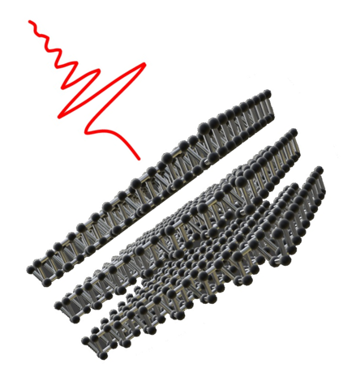
Figure 1. Sketch of black phosphorus’ crystal structure

References
- X. Ling et al., The renaissance of black phosphorus, Proc. Natl. Acad. Sci. 2015, 112, 4523.
- P. Di Pietro et al., Emergent Dirac carriers across a pressure-induced Lifshitz transition in black phosphorus, Phys. Rev. B 2018, 98, 165111.
- N. Adhlakha et al., Terahertz saturable absorption from relativistic hight-temperature thermodynamics in black phosphorus, Phys. Rev. Applied 2023, 20, 054039.

