Terahertz electric-field driven dynamical multiferroicity in SrTiO₃

Matteo Pancaldi^{1,2}, Martina Basini³, Björn Wehinger¹, Mattia Udina⁴, Vivek Unikandanunni³, Terumasa Tadano⁵, Matthias C. Hoffmann⁶, Alexander V. Balatsky^{1,7,8,9} and Stefano Bonetti^{1,3,9}
¹ Department of Molecular Sciences and Nanosystems, Ca’ Foscari University of Venice, 30172 Venice, Italy
² Elettra-Sincrotrone Trieste S.C.p.A., 34149 Basovizza, Italy
³ Department of Physics, Stockholm University, 106 91 Stockholm, Sweden
⁴ Department of Physics and ISC-CNR, “Sapienza” University of Rome, 00185, Rome, Italy
⁵ Research Center for Magnetic and Spintronic Materials, National Institute for Materials Science, Tsukuba 305-0047, Japan
⁶ Linac Coherent Light Source, SLAC National Accelerator Laboratory, Menlo Park, CA 94025, USA
⁷ NORDITA, 106 91 Stockholm, Sweden
⁸ Department of Physics, University of Connecticut, CT 06268, USA
⁹ Rara Foundation – Sustainable Materials and Technologies, 30171 Venice, Italy

The emergence of collective order in matter is among the most fundamental and intriguing phenomena in physics. In recent years, the ultrafast dynamical control and creation of novel ordered states of matter, not accessible in thermodynamic equilibrium, is receiving much attention. Among those, the theoretical concept of dynamical multiferroicity has been introduced to describe the emergence of magnetization by means of a time-dependent electric polarization in non-ferromagnetic materials [1,2]. In simple terms, a large amplitude coherent rotating motion of the ions in a crystal induces a magnetic moment along the axis of rotation, as schematically shown in Figure 1. However, the experimental verification of this effect is still lacking.
With our work [3], we provide the first evidence of room temperature magnetization in the archetypal paraelectric perovskite SrTiO₃ due to dynamical multiferroicity. To achieve it, we resonantly drive the infrared-active soft phonon mode with intense circularly polarized terahertz electric field, and detect a large magneto-optical Kerr effect. A simple model, which includes two coupled nonlinear oscillators whose forces and couplings are derived from ab-initio calculations using self-consistent phonon theory at finite temperature [4], qualitatively reproduces our experimental observations in the time and frequency domains. A quantitatively correct magnitude of the effect is obtained when one also considers the phonon analogue of the reciprocal of the Einstein - de Haas effect, also called the Barnett effect, where the total angular momentum is transferred from the coherent phonon motion to the electrons. Our findings show a new path for designing ultrafast magnetic switches by means of coherent control of lattice vibrations with light.

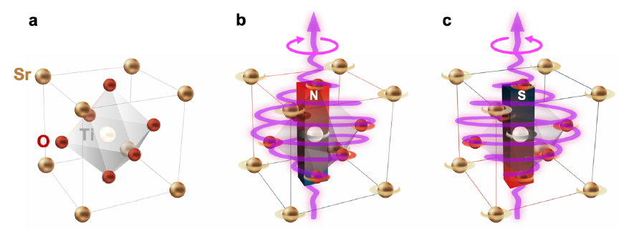
Figure 1. (a) SrTiO₃ unit cell in the absence of a terahertz electric field. When a circularly polarized terahertz field pulse drives a circular atomic motion, dynamical multiferroicity is expected to create a net magnetic moment in the unit cell, with (b) a north pole up for a pulse which is left-handed and (c) a south pole up for a pulse which is right-handed.

- Juraschek, D.M.; Fechner, M.; Balatsky, A.V.; Spaldin, N.A. Dynamical multiferroicity. Phys. Rev. Mater. 2017, 1, 014401.
- Juraschek, D.M.; Spaldin, N.A. Orbital magnetic moments of phonons. Phys. Rev. Mater. 2019, 3, 064405.
- Basini, M.; Pancaldi, M.; Wehinger, B.; Udina, M.; Tadano, T.; Hoffmann, M.C.; Balatsky, A.V.; Bonetti, S. Terahertz electric-field driven dynamical multiferroicity in SrTiO₃. arXiv:2210.01690 [cond-mat.str-el].
- Oba, Y.; Tadano, T.; Akashi, R.; Tsuneyuki, S. First-principles study of phonon anharmonicity and negative thermal expansion in ScF₃. Phys. Rev. Mater. 2019, 3, 033601.

