The LNF IR-THz beamline @ DAϕNE: experimental set-ups and perspectives

Lucilla Pronti ¹, Martina Romani ¹ and Mariangela Cestelli Guidi¹
¹INFN-Laboratori Nazionali di Frascati; lucilla.pronti@lnf.infn.it

The INFN-LNF DAϕNE storage ring produces a powerful source of Synchrotron Radiation in the THz range [1]. The brilliance of SR in the THz domain is up to three orders of magnitude with respect to conventional sources (i.e. mercury lamps), as shown in Figure 1, and the flux increases with the electron current stored. These aspects permit to perform experiments in several field from material science to biology and chemistry and offer the possibility to analyze samples in solid, liquid and gas phases [2-8]. Experimental set-ups available at SINBAD beamline and applications are presented. Moreover, prospectives of the Terahertz (THz) technology applied on cultural heritage field will be described [9,10].

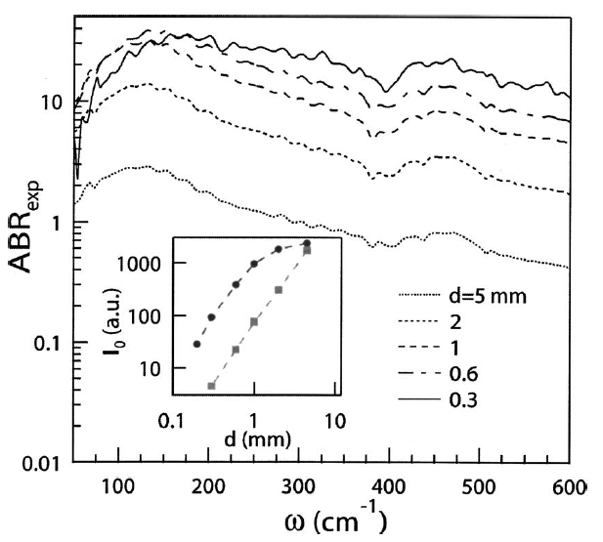

Figure 1. Actual Brilliance Ratio (ABR) between the intensity of SR-SINBAD and a mercury lamp [1].

References

- Cestelli Guidi, M.; Piccinini M., Marcelli A., Nucara A, Calvani P., Burattini E.; Optical performances of SINBAD, the Synchrotron INfrared Beamline At DAϕNE. J. Opt. Soc. Am. 2005, 22, 2810- 2817.
- Cestelli Guidi M., Hotra O., Popov A. I., Optical and Vibrational Spectra of CsCl-Enriched GeS2-Ga2S3 Glasses Halyna Klym, Ivan Karbovnyk, Nanoscale Research Letters, 2016, 11(1):132.
- D’Apuzzo F., Piacenti A. R., Giorgianni F., Autore M., Cestelli Guidi M., Marcelli A., Schade U., Ito Y., Chen M., Lupi S., Terahertz and mid-infrared plasmons in three-dimensional nanoporous graphene, Nature Communications, 2017, 8, 14885.
- Rider M. S., Sokolikova M., Hanham S. M., Navarro-Cia M., Haynes P. D., Lee D. K. K., Daniele M., Cestelli Guidi M., Mattevi C., Lupi S., Giannini V., Experimental signature of a topological quantum dot, Nanoscale, 2020, 12, 22817-22825.
- Giuntini L., Castelli L., Massi M., Fedi M., Czelusniak C., Gelli N., Liccioli L., Giambi F., Ruberto C., Mazzinghi A., Barone S., Marchegiani F., Nisi S., Lubritto C., Altieri S., Tortora L., Branchini P., Fabbri A., Graziani V., Barcellos Lins S., Guidorzi L., Lo Giudice A., Re A., Sottili L., Balerna A., Cestelli Guidi M., Pronti L., Romani M., Albertin F., Bettuzzi M., Brancaccio R.., Morigi M. P., Alloni D., Salvini A., Smilgys B., Prata M., Altieri S., Bonesini M., Di Martino D., Clemenza M., Carpinelli M., Oliva P., Sipala V., Gueli A. M., Pasquale S., Stella G., Pepponi G., Grazzi F., Taccetti F., Detectors and Cultural Heritage: The INFN-CHNet Experience, Applied Sciences, 2021, 11, 3462.
- Tomarchio L., Macis S., D'Arco A., Grilli A., Romani M., Cestelli Guidi M., Hu K., Kukunuri S., Jeong S., Marcelli A., Ito Y., Mou S., Lupi S. Disordered Photonics Behavior from Terahertz to Ultraviolet of a 3- Dimensional Graphene Network, NPG Asia Materials, 2021, 13, 73, 8.
- Tomarchio L., Mosesso L., Macis S., Grilli A., Romani M., Cestelli Guidi M., Zhu Z., Feng X., Zacchigna M., Petrarca M., He K., Lupi S., Electrodynamics of MnBi2Te4 Intrinsic Magnetic Topological Insulator, Electrodynamics of MnBi2Te4 intrinsic magnetic topological insulators, NPG Asia Mater, 2022, 14, 82, 7.
- Tomarchio L., Mosesso L., Macis S., Nguyen L. T., Grilli A., Romani M., Cestelli Guidi M., Cava R. J., Lupi S., Phonon Anharmonicity and Spin–Phonon Coupling in CrI3, Materials, 2023, 16, 4909.
- Cosentino A., Terahertz and Cultural Heritage Science Examination of Art and Archaeology, Technologies, 2016, 4(6), 1-13
- Fukunaga K., THz Technology Applied to Cultural Heritage in Practice, Springer Tokyo, 2016, 144.

