Infrared Plasmons in Quantum Materials
Salvatore Macis,*^{1,2}, Lorenzo Mosesso^{1,} Luca Tomarchio¹, Stefano Lupi¹
¹ ¹ Department of Physics, Sapienza University, Piazzale Aldo Moro 5, 00185, Rome, Italy.
² INFN - Laboratori Nazionali di Frascati, via Enrico Fermi 54, 00044, Frascati (Rome), Italy

Main text:

Surface plasmons, the collective oscillations of electrons in metals and doped semiconductors, show outstanding electromagnetic (EM) properties spanning from a reduced wavelength in comparison to that of an exciting electromagnetic field, an extreme electric field enhancement several orders of magnitude larger than the incident field, to several nonlinear effects like harmonic generation and optical rectification. Although conventional metals, like gold and silver, are usually used in plasmonics, non-conventional and exotics materials now on the scientific edge, providing additional properties like plasmon tunability due to their extreme sensitivity to external parameters like doping, temperature, and electric and magnetic fields.
In this work we present the generation of surface plasmon polariton in two quantum materials, patterned in the form of micro-ribbon arrays: the ultrahigh conductive PdCoO₂ oxide and the Wey-II semimetal PtTe₂.
PdCoO₂ layered delafossite is the most conductive compound among metallic-oxides, with a room-temperature resistivity of nearly 2 µΩcm, corresponding to a mean free path of about 600Å¹. These values represent a record considering that the charge density of PdCoO₂ is three times lower than copper [1]. PtTe₂ is a Weyl semimetal, with topological nontrivial properties and the highest room-temperature electrical conductivity among metallic Transition Metal Dichalcogenides [2]. By changing the width W and period 2W of the ribbon arrays, we select suitable values of the plasmon wavevector q, experimentally sampling the surface plasmon dispersion (see Fig.1 for PdCoO₂) in the mid-infrared electromagnetic region. Near the ribbon edge, we observe a strong field enhancement due to the plasmon confinement, indicating both materials as a promising infrared plasmonic candidates [3,4].

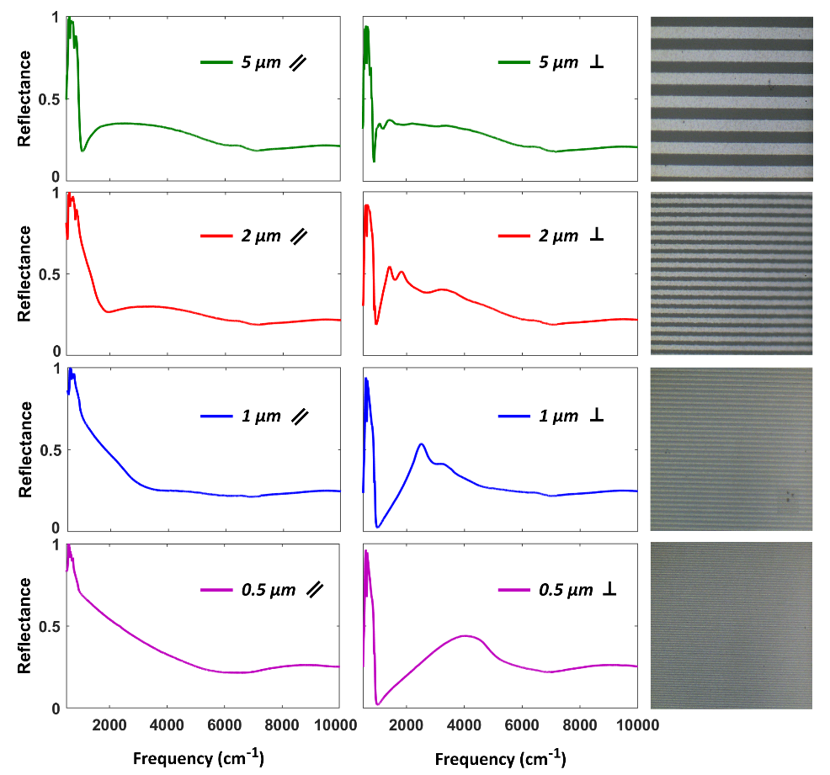
Figure 1. Fig.1. Reflectance of the four patterned films of PdCoO₂, with the radiation electric field parallel to the ribbons (left column) and perpendicular to the ribbons (right column). On the right are displayed the optical microscope images of the PdCoO₂ patterned films with different widths W and periods 2W

- Brahlek, M. et al. Growth of metallic delafossite PdCoO₂ by molecular beam epitaxy. Phys. Rev. Mat. 3, 093401 (2019).
- Hao, S. et al. Low-Temperature Eutectic Synthesis of PtTe₂ with Weak Antilocalization and Controlled Layer Thinning Adv. Funct. Mater., 28, 1803746 (2018).
- Macis, S. et al., Infrared Plasmons in Ultrahigh Conductive PdCoO₂ Metallic Oxide. Communications Physics, 5(1), 1-6, (2022).
- Macis, S. et al. Terahertz and Infrared Plasmon Polaritons in PtTe2 Type-II Dirac Topological Semimetal Nature Communications, submitted (2023).

