High repetition rate THz generation by cavity enhanced optical rectification in GaP

Francesco Canella^{1,*}, Edoardo Suerra^{2,3}, Dario Giannotti^{4,3}, Simone Cialdi^{2,3}, and Gianluca Galzerano^{1,3}
¹Istituto di Fotonica e Nanotecnologie – CNR, piazza Leonardo da Vinci 32, Milano, Italy
²Dipartimento di Fisica, Università degli Studi di Milano, via Celoria 16, Milano, Italy
³INFN, Sezione di Milano, via Celoria 16, Milano, Italy
⁴Dipartimento di Fisica, Politecnico di Milano, piazza Leonardo da Vinci 32, Milano, Italy
*francesco.canella@cnr.it

Abstract: We report on the experimental characterization of a GaP nonlinear crystal inserted within an enhancement resonator pumped by high-repetition rate near-infrared pulses for the generation of milliwatt-level THz radiation.

1. Introduction
Terahertz (THz) radiation exhibits properties of great interest and potential applications in several scientific fields. For example, THz waves (in the spectral range between 0.1 and 30 THz) find direct applications in spectroscopy of innovative materials, time-domain quantum optics, and biological sensing [1]. However, THz science remains challenging because of the lack of suitable sources and detectors. To fill this technological gap, various techniques have been explored over the years. For instance, quantum cascade lasers and photoconductive antennas are well-established methods to generate THz radiation [2]. Recently, frequency down-conversion of near-infrared light in nonlinear crystals emerged as a powerful alternative to more traditional methods. In particular, optical rectification schemes based on ytterbium (Yb) ultrafast lasers are now considered extremely promising [3]. Moreover, the use of an enhancement resonator able to store the infrared pulses from the Yb laser source boosts the power that can be used for optical rectification [4]. However, high-average power leads to a high thermal load for the nonlinear crystal. In addition, spatial deformation of the resonant mode can occur when the crystal is under stress inside the cavity, causing power losses and THz power drops. A crystal widely used is Gallium Phosphide (GaP) [5]. Recently, Hekmat et al. [6] published an extensive study on the behavior of this crystal when used for single pass optical rectification in the presence of high power. In this work, we propose a preliminary study in a slightly different regime of operation for GaP crystals, exploiting an enhancement resonator to achieve an average power > 300 W. This offers the chance to investigate the material properties at very high power together with the possibility of understanding the effect of GaP-induced mode deformation inside an enhancement cavity. We propose an experimental setup based on a amplified Yb fiber mode-locking laser (spectral width ~ 7 nm around 1035 nm) with a repetition rate of nearly 100 MHz, with maximum power of 60 W, and a pulse length of 370 fs. The amplified pulses are boosted to nearly 300 W using an enhancement cavity inside which optical rectification in a GaP crystal takes place. This way, modal instabilities and high-power-induced effects on GaP are observable and characterizable together with the THz generation efficiency. Even if modal instabilities partially limit the maximum gain achievable with the enhancement cavity, the comprehension of the phenomenon will soon allow the implementation of mitigation strategies to fully exploit the advantage of optical rectification in an enhancement cavity for the high repetition rate and the milliwatt level average power THz generation, opening the way to promising applications in the THz region.

2. Intracavity optical rectification experiment
The experimental setup for intracavity THz generation is shown in Figure 1a. A Yb mode-locked fiber laser produces pulses at 1035 nm with a 92.857-MHz repetition rate. A high-power fiber amplifier raises the average power to a maximum of 60 W. Chirped volume Bragg gratings are used to stretch and recompress the pulse length to 370 fs. Then the laser pulses are coupled to an enhancement cavity, where they interact with an AR-coated GaP crystal to produce THz waves via optical rectification. Initial tests have been performed with a 2-mm tick crystal, but we plan to compare the performances with 1-mm and 0.5-mm crystals. The interaction area is ~ 1 mm². The cavity design recalls the one already exploited for previous studies with different applications that can be found in Refs. [7,8]. As a difference, the finesse is lowered by the presence of the GaP crystal (losses ~ 10%), increased group delay dispersion, and low reflectivity of the input coupler (84%). The resonant mode is monitored with a CCD camera outside the cavity. We estimate a maximum gain factor of 14. This way, at the interaction point with the GaP, powers > 300 W can be reached.
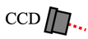
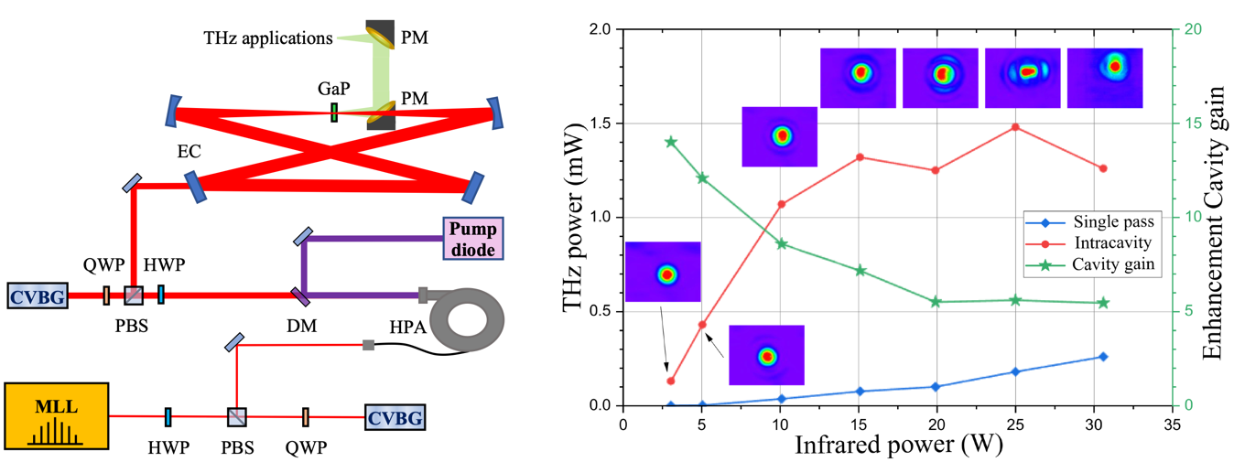
Fig. 1. Panel (a): Experimental setup. MLL: mode-locked laser, HWP/QWP: half /quarter waveplate, CVBG: chirped volume Bragg grating, HPA: high power amplifier, DM: dichroic mirror, EC: enhancement cavity, PM: parabolic mirrors. Panel (b): Generated THz power in single pass configuration and with an enhancement resonator (left axis) and cavity gain (right axis) as a function of infrared laser power. Cavity modes acquired with CCD camera are shown for each power.

THz power ($μW)$
(a)
(b)

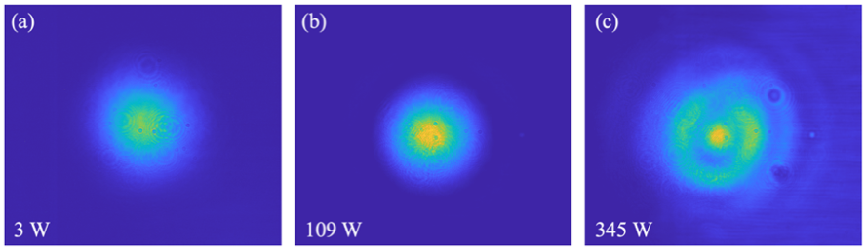
In Figure 1b we show the generated THz power in single pass configuration (GaP outside the cavity) and using the enhancement cavity. The cavity power gain is also shown. For a given laser power, the enhancement cavity boosts the power on the GaP and the generated THz. On the other hand, for an increasing incident power, the cavity gain decreases. This is a symptom of a laser-cavity decoupling, mainly due to modal degeneration and thermal lensing caused by local changes in the refractive index in the GaP. Then, the enhancement cavity fundamental mode overlaps with higher-order modes, and losses rise. The mode change with power is shown in the insets of Fig. 1b. In Fig. 2 a comparison between the cavity modes at intracavity power of 3 W, 109 W, and 345 W is presented. For power higher than 100 W (Figs. 2b and 2c), the fundamental mode is clearly superimposed with larger modes. Analyzing the mode images acquired with the CCD camera it is possible to extract quantitative information on the GaP behavior at different powers and temperatures. The results of such analysis will be presented at the MICS 2023 Conference in Vienna, together with THz generation data at maximum power and a comparison among different GaP thicknesses. To mitigate the mode instabilities of GaP, we propose to introduce a telescope with variable convergence inside the cavity, that might compensate for the thermal lensing effects of the GaP. At the moment, only preliminary tests with the intracavity telescope have been done.
Fig. 2. Cavity modes at different powers on the GaP: (a) 3W, (b) 109W, and (c) 345 W.
3. Conclusions
We proposed a simple experimental setup for the generation of THz pulses with a high repetition rate via optical rectification of a Yb mode-locked laser in a GaP crystal inside an enhancement cavity. We showed that the use of an enhancement resonator can boost the generation efficiency although some drawbacks coming from the high average power arise. We investigated the behavior of the GaP crystal at high power, to suggest mitigation strategies and further increase the efficiency of THz generation of the setup.
4. References
[1] A. Leitenstorfer et al., “The 2023 terahertz science and technology roadmap,” J. Phys. D: Appl. Phys. 56, 22, ﻿223001 (2023).
[2] ﻿P. U. Jepsen et al., “﻿Terahertz spectroscopy and imaging – Modern techniques and applications,” ﻿Laser Photonics Rev. 5, 1, 124-166 (2011).
[3] J. Drs at al., “﻿﻿Optical rectification of ultrafast Yb lasers: pushing power and bandwidth of terahertz generation in GaP﻿,” JOSA B 36, 11, ﻿3039 (2019).
[4] Suerra et al. "Generation of high repetition rate THz radiation at the millwatt-level via optical rectification in an enhancement cavity," EPJ Web of Conferences, 08021 (2023).
[5] ﻿J. Li et al., “﻿Generation of 0.3 mW high-power broadband terahertz pulses from GaP crystal pumped by negatively chirped femtosecond laser pulses,” ﻿Laser Phys. Lett. 10, 125404 (2013).
[6] N. Hekmat et al., “﻿Cryogenically cooled GaP for optical rectification at high excitation average power,” Opt. Mater. Express 10, 11, 2768 (2020).
[7] E. Suerra et al., “A new method for spatial mode shifting of stabilized optical cavities for the generation of dual-color X-rays”, NIM-A 1019, 165852 (2021).
[8] F. Canella et al., "﻿Low frequency-to-intensity noise conversion in a pulsed laser cavity locking by exploiting carrier envelope offset," Appl. Phys. B, 128, 11, 205 (2022).

