THz-photonics by all-dielectric phonon-polariton nonlinear nanoantennas

Unai Arregui Leon¹, Davide Rocco^{2,3}, Luca Carletti^{2,3}, Marco Peccianti⁴, Stefano Maci⁵, Giuseppe Della Valle^{1,6}, and Costantino De Angelis^{2,3}
¹Politecnico di Milano, Department of Physics, Piazza Leonardo da Vinci 32, Milano 20133, Italy
²University of Brescia, Department of Information Engineering, via Branze 38, 25123 Brescia, Italy
³National Institute of Optics, Consiglio Nazionale delle Ricerche, via Branze 45, 25123 Brescia, Italy
⁴University of Sussex, Emergent Photonics Lab (EPic), Dept. of Physics and Astronomy, Brighton, BN1 9QH, United Kingdom
⁵University of Siena, Department of Information Engineering and Mathematics, 53100 Siena, Italy
⁶Institute for photonics and nanotechnologies, CNR, Piazza Leonardo da Vinci 32, Milano 20133, Italy
* corresponding author: e-mail davide.rocco@unibs.it
The THz spectrum offers the potential of a plethora of applications, ranging from the imaging through non transparent media to wireless-over-fiber communications and THz-photonics. The latter framework would greatly benefit from the development of optical-to-THz wavelength converters. Exploiting Difference Frequency Generation in a nonlinear all dielectric nanoantenna, we propose a compact solution to this problem. The approach is completely transparent with respect to the modulation format and can be easily integrated in a metasurface platform for simultaneous frequency and spatial moulding of THz beams.
Keywords: photonic metasurfaces, THz photonics
INTRODUCTION
The terahertz (THz) region of the electromagnetic spectrum has gained increasing attention in the last decades and today it is one of the fundamental emerging branches of research for the broad photonics community.
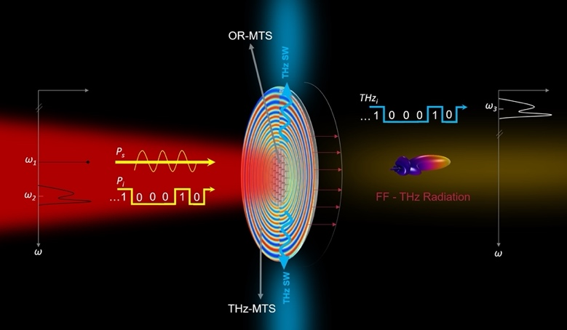
Astrophysics, communications, imaging, spectroscopy, biotechnology and security are among the huge plethora of applications where THz technology can provide ground-breaking devices and systems, also thanks to the particular features of a wide range of media in the THz spectral range [1, 2, 3]. Noteworthy, metasurfaces are today identified as the framework where all the above approaches can be conveniently unified to provide a compact and integrable solution to a variety of different beam forming needs. For example, in Fig. 1 the THz surface wave is beam formed into the far-field (FF) THz radiation by a modulated THz metasurface, providing gain and directionality.
Figure 1: The wavelength converter: the information message, with power Pi, mixes with the incident signal, power Ps, both in the IR region. DFG in the all-dielectric nanoantennas emitting the THz information signal, THz, to produce a THz surface wave (SW) which propagates in the surrounding THz metasurface where it is converted into the desired THz radiation in the far-field (FF).
Recently, in order to get the highest performance per unit volume via resonant, nanoscale, compact platforms, THz generation by optical rectification in plasmonic Split-Ring Resonators (SRRs) has been reported [4]; the THz signal is produced from nanoscale SRRs by exciting magnetic-dipole modes in the infrared regime. A thorough study of THz pulse generation using a 40 nm thin metasurface based on plasmonic SRRs excited with a laser oscillator emitting nanojoule femtosecond pulses has been reported, measuring a conversion efficiency as high as that of a 0.1 mm thick ZnTe crystal. Despite these pioneering results, a breakthrough in the field demands for a substantial improvement of the conversion efficiency at the nanoscale.
One promising alternative to plasmonic THz emitters is represented by all-dielectric THz antennas. As schematically depicted in Fig. 1, exploiting DFG driven by second-order nonlinearities in a nonlinear all dielectric nanoantenna, we have proposed this wavelength converter in [5, 6]. As a prototype example, for an AlGaAs nanoantenna, we calculate a strong conversion efficiency around 11 THz for an optimized structure. Moreover, we also stress that the same approach can be applied also using different materials with second-order nonlinearity, such as LiNbO₃, to access different spectral regions [7].

RESULTS
Let us imagine a scenario in which a dielectric metasurface generates a THz signal through DFG process when excited with pumps in the infrared regime, see Fig. 1. To demonstrate this statement, we aim to exploit nonlinear DFG process in an all-dielectric nanoantenna of AlGaAs crystalline structure. Indeed, starting from two intense laser beams in the infra-red, the DFG nonlinear generated field can have a frequency of few THz, thus laying within the THz gap window. Although there exist other compounds that possess zincblende structure, the choice of AlGaAs is rather advantageous for our purpose, due to its low loss and dispersion in the optical region, high refractive index, large nonlinear susceptibility of the second-order as well as a well-established fabrication techniques.
Let us consider an AlGaAs nanocylinder free-standing in air, with radius r equal to 200 nm and height h of 400 nm. The geometrical parameters of the nanodisk are selected in order to fulfill a magnetic dipolar resonance around the fundamental wavelength. We consider two incident pump beams that excite the proposed nanodisk in the infra-red range. Thus, two spectrally close components of the input optical pulses are mixed via the DFG process, so that the terahertz component is generated.
The role of localized surface phonon-polaritons (SPhP) can be investigated by resorting to a reduced quasi-static model of the THz generation process.
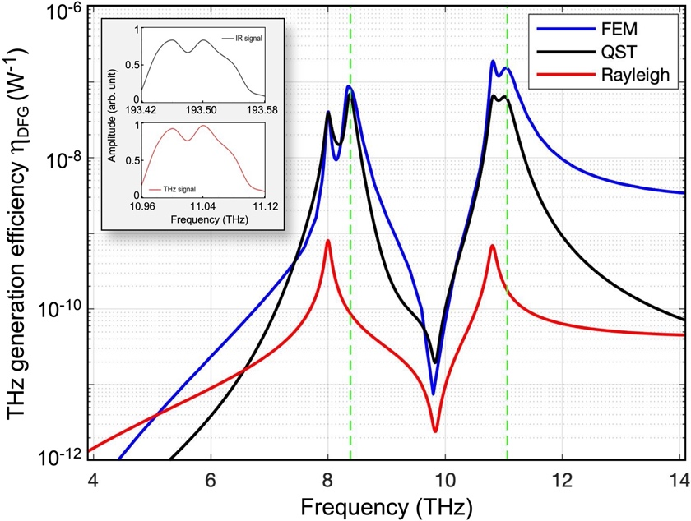
A fair qualitative agreement with the extinction efficiency evaluated from FEM numerical analysis (blue trace in Fig. 2) is retrieved. Note that if one considers non-resonant extinction from the Rayleigh background, the estimated DFG efficiency would drop by almost two orders of magnitude on the efficiency peaks (red curve in Fig. 2). This ascertains the key role of SPhP in the THz generation from all-dielectric nonlinear nanoantennas.
Figure 2: Conversion efficiency for THz generation by DFG in the proposed AlGaAs nanoantenna, evaluated from FEM numerical analysis (blue), and reduced model with (black) or without (red) contribution from phonon permittivity. The inset shows the negligible spectral distorsion introduced by the proposed transceiver.
Lastly, to further highlight the potential of the proposed structure for THz applications, we perform a comparison with state-of-the-art configurations, based on a plasmonic structure. We consider an isolated gold split-ring resonator with similar geometrical parameters as the one reported in [4]. Such THz generation efficiency simulations retrieve 7 orders of magnitude lower than what is attained with the proposed single AlGaAs nanopillars. Hence, using high-refractive index dielectric materials not only strongly enhances the DFG process thanks to the bulk nonlinear coefficient and THz SPhP oscillations, but also provides, from a simple cylindrical geometry of the antenna, a configuration of the nonlinear radiation pattern that is suitable for launching surface waves in THz metasurfaces.
References
- L. Peters, J. Tunesi, A. Pasquazi, M. Peccianti, Sci. reports 7, 1–9 (2017).
- M. Faenzi, D. Gonzalez-Ovejero, S. Maci, IEEE Transactions on Antennas Propag. 69, 1942–1951 (2020).
- M. Fang, Opt. express 26, 14241–14250 (2018).
- M. Tal, S. Keren-Zur, T. Ellenbogen, ACS photonics 7, 3286–3290 (2020).
- U. A. Leon, D. Rocco, L. Carletti, M. Peccianti, S. Maci, G. Della Valle, C. De Angelis, Sci Rep 12, 4590 (2022).
- U. A. Leon, L. Carletti, D. Rocco, C. De Angelis, G. Della Valle, Laser Photonics Rev., 2300669 (2023).
- L. Carletti, C. McDonnell, U. A. Leon, D. Rocco, M. Finazzi, A. Toma, T. Ellenbogen, G. Della Valle, M. Celebrano, C. De Angelis, ACS Photonics 10 , 3419 (2023).

