“THz Optics for Beam Tailoring
by Form-Birefringence”

Can Koral^{1,2,*}, Zahra Mazaheri^{2,3} and Antonello Andreone^{2,3}
¹ Department of Science, University of Basilicata, 85100 Potenza, Italy;
²National Institute of Nuclear Physics, Naples Unit, Naples, 80126, Italy;
³Department of Physics, University of Naples “Federico II”, 80126 Napoli, Italy;
* can.koral@unibas.it

We present the recent advances achieved on the design, fabrication, and experimental validation of THz all-dielectric optical devices for beam tailoring and phase front shaping. There is a growing interest on optical components and devices for THz beam tailoring and controlled manipulation over its amplitude, phase and polarization states for probing and controlling a variety of complex phenomena[1]. Advanced electromagnetic field profiles can be attained under the controlled manipulation of spatial amplitude and/or phase over the plane of incidence. Some examples include plasmonic structures using graphene-based hybrid waveguides, axially symmetric wave plates using liquid crystals or intrinsically birefringent crystals and optical elements using periodically structured dielectric interfaces. The birefringence associated with the use of periodic structures is called “form birefringence” and has been widely applied to realize various THz optical components and devices [2]. We first realized a $λ/4$ plate as the main design element (Figure 1.a). The form-birefringence concept and its possible adaptation to additive manufacturing techniques were analytically evaluated and experimentally measured by THz time domain spectroscopy and polarization-sensitive imaging techniques. The full position-dependent electric field spatial maps and the corresponding polarization distribution maps were acquired. Then, we adapted this concept to realize a large surface area phase shifter plate (Figure 1.b) consisting of two wave plate zones coupled in a perpendicular orientation and enabling the creation of quasi-ideal phase retardation in between the two planes with a good uniformity [3]. Finally, we realized a q-plate (Figure 1.c) consisting of space-variant slabs enabling the realization of radial and azimuthal vector beams at discrete frequency intervals [4].

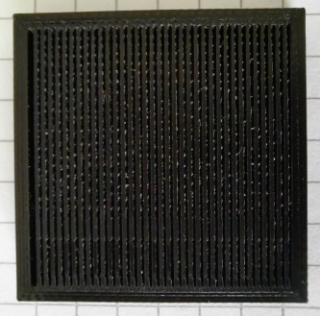a | 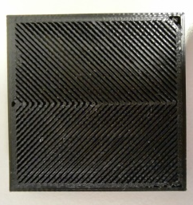b | 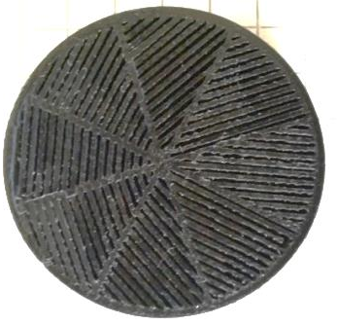c
Figure 1. The realized THz Optical devices a)$λ/4$ wave plate b) Phase Shifter plate c) q-Plate

References
1. Koral, C.; Mazaheri, Z.; Papari, G.P.; Andreone, A.; Drebot, I.; Giove, D.; Masullo, M.R.; Mettivier, G.; Opromolla, M.; Paparo, D.; et al. Multi-Pass Free Electron Laser Assisted Spectral and Imaging Applications in the Terahertz/Far-IR Range Using the Future Superconducting Electron Source BriXSinO. Front. Phys. 10, 1–18 (2022). doi:10.3389/fphy.2022.725901.
2. Scheller, M.; Jördens, C.; Koch, M. Terahertz Form Birefringence. Opt. Express 18, 10137-10142 (2010). doi:10.1364/oe.18.010137.
3. Koral, C.; Mazaheri, Z.; Andreone, A. A Large Area Wide Bandwidth THz Phase Shifter Plate for High Intensity Field Applications. Photonics 10, 825 (2023). doi:10.3390/photonics10070825.
4. Koral, C.; Mazaheri, Z.; Andreone, A. THz Multi-Mode Q-Plate with a Fixed Rate of Change of the Optical Axis Using Form Birefringence. Micromachines 13, 796 (2023). doi:10.3390/mi13050796.

