Terahertz imaging for the detection of cimiciato-infected hazelnuts.
Fulvia Gennari^{a,*}, Mario Pagano^{b}, Alessandra Toncelli^{a,c,d,e}, Maria Tiziana Lisanti^{f}, Riccardo Paoletti^{c,g}, Pio Federico Roversi^{h}, Alessandro Tredicucci^{a,d,e}, Matteo Giaccone^{i}

a. Dipartimento di Fisica “E. Fermi”, Università di Pisa, Largo B. Pontecorvo 3, 56127 Pisa, Italy.
b. Institute of Research on Terrestrial Ecosystems, National Research Council, Via Madonna del Piano 10, 50019 Sesto Fiorentino, Italy
c. Istituto Nazionale di Fisica Nucleare, Sezione di Pisa, Largo B. Pontecorvo 3, 56127 Pisa, Italy.
d. Centro per la Integrazione Della Strumentazione Dell’Università di Pisa (CISUP), Lungarno Pacinotti 43/44, 56126, Pisa, Italy.
e. Istituto Nanoscienze – CNR, Piazza S. Silvestro 12, Pisa, 56127, Italy.
f. Università degli Studi di Napoli Federico II, Dipartimento di Agraria, Sezione di Scienze della Vigna e del Vino, viale Italia, 83100 Avellino, Italy
g. Dipartimento di Scienze Fisiche, della Terra e dell’Ambiente, Sezione di Fisica, Università di Siena, via Roma 56, 53100 Siena, Italy.
h. CREA, Research Centre for Plant Protection and Certification, Firenze, Italy
i. Institute for Mediterranean Agricultural and Forestry Systems, National Research Council, 80055 P.le Enrico Fermi 1 - Loc. Porto del Granatello, 80055 Portici, Naples, (Italy).

In recent years, hazelnut cultivation is becoming increasingly important in terms of areas invested and crops expected. Among the various quality defects, one of the most detrimental alterations to hazelnut quality is “cimiciato” defect, which is caused by a group of insects belonging to the families of Coreidae and Pentatomidae. Nowadays no reliable automatic method to discriminate between healthy and cimiciato hazelnuts exists and the food industry still relies on manual visual inspection of shelled nuts.
The aim of this work was to validate a continuous-wave terahertz transmission imaging system to discriminate cimiciato-infected hazelnuts by a non-invasive method that can, potentially, be implemented in a real-time approach. Carrying low-energy photons, THz radiation is unable to induce ionization processes, which means that it is a perfectly safe radiation for biological tissues.
The trial was conducted on a sample of 150 hazelnuts. We set up a classification model and to assess its performance we used a validation sample of 50 hazelnuts. We plotted the distributions of the healthy and injured samples and fitted the two curves with a polynomial function. The data from each unknown nut was added as a new data point to each of the two distributions, and the minimum distance between this new point and the fitting function was calculated. The new data point was, then, assigned to the distribution with the lower distance and the correct/incorrect attribution was evaluated by visual inspection of the nuts. The procedure was able to correctly identify 100% of cimiciato hazelnuts in the mixed population with still a 25% false negative rate.
The developed method is simple, requires a low-cost apparatus and can potentially be implemented in real time, therefore, it can be of great interest for the food industry.
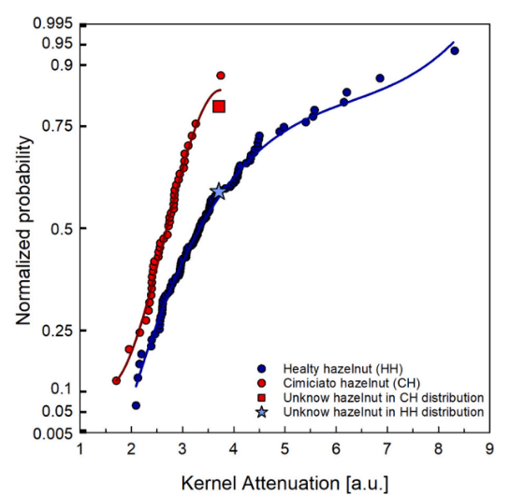
Figure 1: Probability plot of the two different distributions of healthy hazelnuts (HH) and cimiciato hazelnuts (CH) with the fit superimposed and an example of placing an unknown hazelnut in the HH (star) and CH (square) distributions.

Mail:
Fulvia Gennari: fulvia.gennari@phd.unipi.it
Mario Pagano: mario.pagano@cnr.it
Alessandra Toncelli: alessandra.toncelli@unipi.it
Maria Tiziana Lisanti: mariatiziana.lisanti@unina.it
Riccardo Paoletti: riccardo.paoletti@gmail.com
Pio Federico Roversi: piofederico.roversi@crea.gov.it
Alessandro Tredicucci: alessandro.tredicucci@unipi.it
Matteo Giaccone: matteo.giaccone@cnr.it

